Lab setup I would need for this trg (Unless the client has already specified their requirements)

1. JDK version 17 : https://www.oracle.com/in/java/technologies/downloads/#jdk17-windows

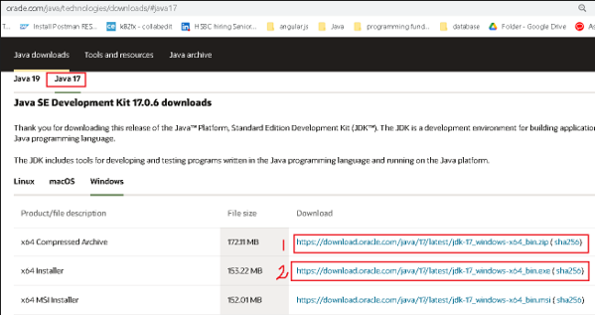

You can either

* + download zip (in which case, trainees will need admin access to environment variables)
  + download exe installer and install JDK

1. Eclipse version : eclipse-jee-2022-12-R-win32-x86_64.zip  (https://www.eclipse.org/downloads/packages/ )
2. internet access for Java documentation etc
3. spring-tool-suite-4-4.8.0.RELEASE-e4.17.0-win32.win32.x86_64.self-extracting  (https://spring.io/tools)

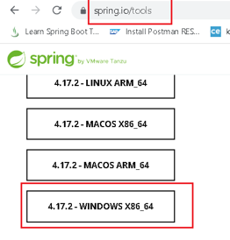

1. Tomcat 8/9 (https://tomcat.apache.org/download-80.cgi)
2. Postman (To test REST services)(<https://www.postman.com/downloads/>)
3. Oracle 11g XE ([https://www.oracle.com/database/technologies/xe-prior-release-downloads.html](https://www.oracle.com/database/technologies/xe-prior-releases.html) ).

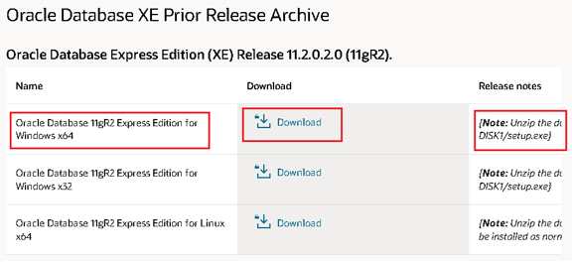

You will find it here. Unzip and then run DISK1/setup.exe

Follow the wizard. Username is **SYSTEM** for which I gave password as “**user1**”. Confirmed password too